Here’s a comprehensive project report based on your outline:

### **1. Title Page**

**Project Title:** Christmas Sales Trend Analysis  
**Created By:** Ashwini Upadhya

### **2. Table of Contents**

1. Title Page
2. Table of Contents
3. Executive Summary
4. Problem Statement
5. Objectives
6. Data Overview
7. Methodology
8. Visualizations and Analysis
9. Results and Findings
10. Recommendations
11. Challenges and Limitations
12. Future Work
13. Conclusion
14. References
15. Appendices

### **3. Executive Summary**

This project explores sales data using Tableau to identify trends, evaluate performance, and generate actionable insights. The objective was to analyze data across various locations and product categories to inform strategic decision-making. Key findings include seasonal trends, customer preferences, and underperforming areas, along with recommendations for improvement.

### **4. Problem Statement**

Analyze and visualize sales data across various categories to identify trends and customer preferences during the holiday season. The goal is to optimize category-wise sales performance, enhance customer engagement, and uncover insights for better decision-making using Tableau's interactive features.

### **5. Objectives**

* Understand sales and profit trends across locations and categories.
* Identify seasonal impacts and underperforming areas.
* Enable data-driven decision-making to optimize sales strategies.

### **6. Data Overview**

**Data Sources:** Internal company databases, including sales, location, and product details.  
 **Data Description:** Structured data with attributes like category, location, total price, and profit.  
 **Data Preparation:**

* Handled missing values.
* Transformed data for consistency.
* Joined datasets based on common fields.

### **7. Methodology**

* Tools Used: Tableau for visualization, Excel for data cleaning.
* Process:
  + Imported cleaned datasets into Tableau.
  + Built visualizations for trends, correlations, and anomalies.
  + Applied filters and calculated fields for deeper insights.
* Techniques: Trend analysis, seasonal pattern identification.

### **8. Visualizations and Analysis**

**Visualization:** SalesOverview and Trend  
**Purpose:** Used for monitoring sales trends, profitability, and product category performance.

**Dashboard:**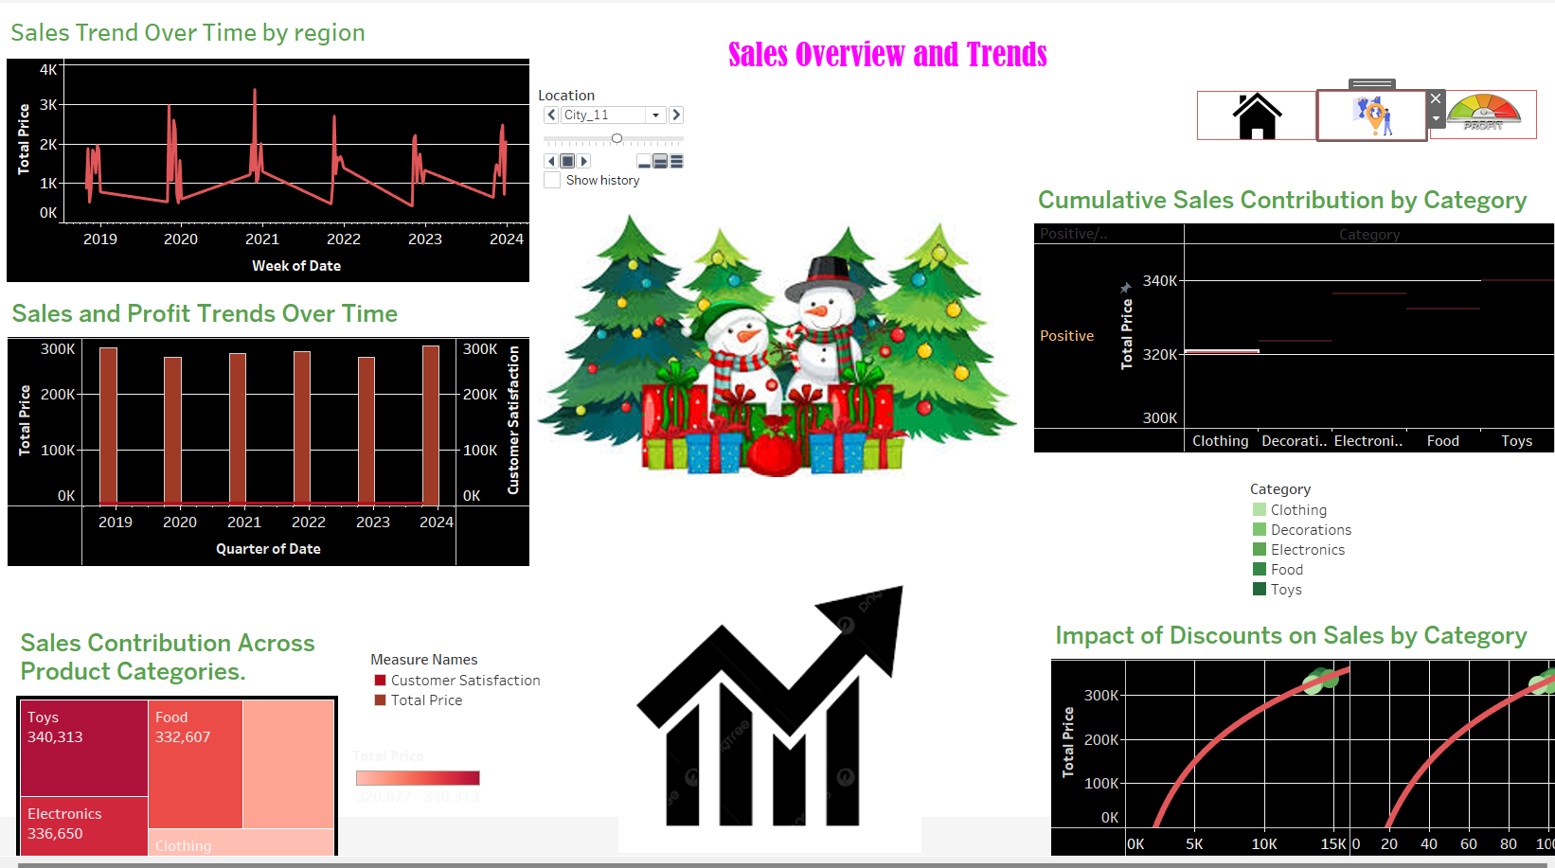

**Insights:** Sales fluctuate seasonally, profits are low, and Toys, Electronics, and Food drive revenue.

**Visualisation:** Regional and Category Insights

**Purpose:**Analyze sales performance across regions, time, and product categories.

**Dashboard:**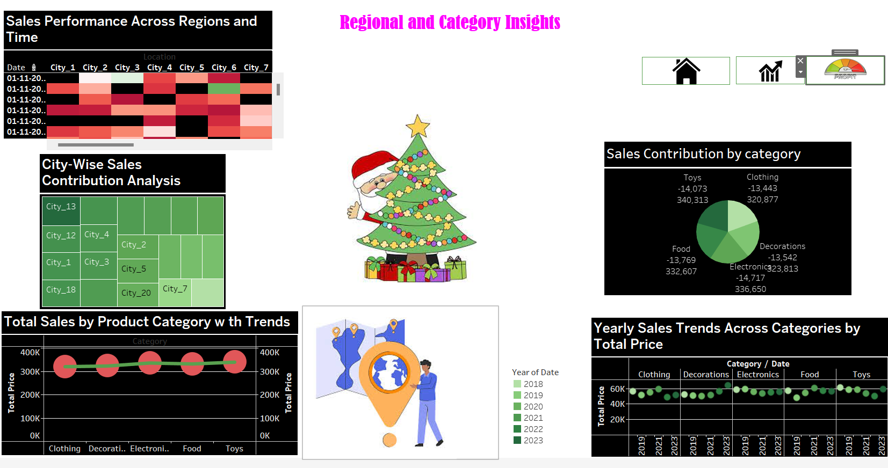

**Insights:** Sales vary across cities & time, Toys & Electronics drive revenue.

**Visualisation:** Sales and Profit Analysis

**Purpose:** Track sales, profits, and identify areas for improvement.

**Dashboard:** 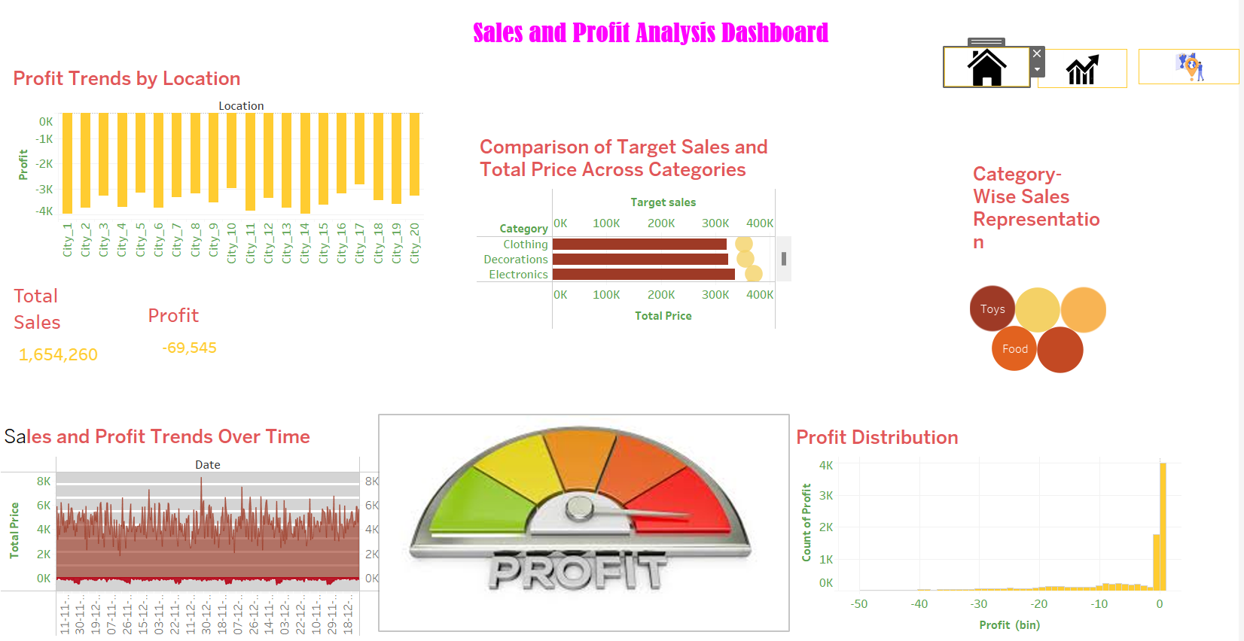

**Insights:** Most locations show losses, Toys & Electronics dominate sales.

### **9. Results and Findings**

* Sales exhibit seasonality with regional variations. Consistent sales across years require deeper profit analysis. Toys, Electronics, and Food drive sales, while Clothing and Decorations lag. Discounts significantly impact sales, especially for Food and Toys. Festive theme highlights the importance of seasonal campaigns.
* Sales vary across cities & time, with City_6/7 showing peak activity. City_13/12 lead in sales contribution. Clothing & Electronics dominate sales. Categories exhibit consistent trends over time, with Clothing leading. Visuals include festive elements & financial icons.
* Most cities show negative profits, indicating potential pricing, cost, or operational issues. Toys and Food dominate sales, while some categories lag behind target sales. Sales are consistent but profits are minimal or negative, with most transactions yielding little profit. High sales volume is offset by negative overall profit.

### **10. Recommendations**

* Focus marketing efforts on top-performing categories during peak seasons.
* Investigate reasons behind low performance in specific locations and address challenges.
* Diversify product offerings in underperforming categories.

### **11. Challenges and Limitations**

* Limited data on external factors like competitor performance and market trends.
* Time constraints restricted deeper analysis of customer demographics.
* Data quality issues required significant preprocessing.

### **12. Future Work**

* Incorporate customer demographic data for more personalized insights.
* Use advanced analytics like predictive modeling for sales forecasting.
* Expand analysis to include competitor data for a holistic market view.

### **13. Conclusion**

The project provided critical insights into sales performance and customer behavior. By leveraging Tableau’s visualizations, actionable strategies were developed to improve underperforming areas and capitalize on strengths. This analysis underscores the value of data-driven decision-making.